26.30: a)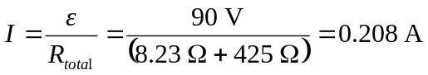
b) 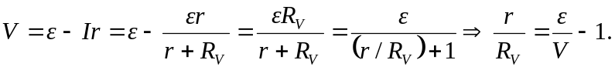
Now if V is to be off by no more than 4% it requires: 